Autonomous Vehicles and Bicycle Interactions

**Contextual Background Story**

A friend of mine, who I’ll call Tom for the sake of his privacy, came home one day with a bandaged hand, bruised face, and a general look of shock and bewilderment. He had just come from the hospital after hitting a car on his bike. A negligent happenstance for some, but a truly unlucky feat for Tom.

Here’s what he told me:

While riding into town, post-COVID shutdowns, the streets were empty. This was around the start of quarantine, early April 2020 - hardly anyone was out. Nonetheless, Tom encountered one vehicle on his way.

After shooting down a short, but steep hill, Tom came up on a midsized SUV. He was still coasting from the downhill and hoped to use this momentum for an easier ride on the subsequent flat part coming into town.

Tom was accelerating so fast from the momentum, he started making moves to pass the car ahead of him. As he was coming up on the car’s back right bumper, but still a reasonable distance behind, a pedestrian streaked across the road ahead of the car. As Tom put it, the guy appeared out of nowhere, whooped and sprinted through the crosswalk, then disappeared into a nearby park. And though the car was still a good distance from the crosswalk, it executed a full stop, causing the back wheels to swing into the bike lane.

Tom, still trying to maximize his speed from the downhill, ran arm-first into the back window, while his face swung around and hit the side of the car. His hand, probably in trying to brace himself, punched through the bottom right corner of the back window and his arm went through all the way up to the shoulder.

While this may seem like a clear case of an overreactive driver, the driver, in fact, was not at fault. Instead, the car, a fresh-off-the-lot 2021 vehicle installed with an automatic emergency braking system (AEB), had made the decision to stop. Even though the car was far enough from the pedestrian for the driver to consciously reduce his speed, and even though the whooper/sprinter was speeding so fast through the crosswalk that the car wouldn’t have hit him regardless (according to Tom), the car had recognized a potential target and literally skidded to a halt.

Both Tom and the driver paid for it, the driver in repairing his new car, and Tom with his medical bills and newly cracked bike frame.

**So what does this mean?**

I believe there are several takeaways from this story, perhaps the least of which is the question of when it’s prudent for a cyclist to rely on coasting. Tom had hoped to use the momentum from the downhill to ease his pedaling; something I think most experienced cyclists have leant on passive energy for speed and ease of riding (plus, there’s a special kind of satisfaction derived from passing a car on your bike, especially while half-coasting). This particular bought of coasting however, put him in the line of crossfire as he was attempting to pass the vehicle. Which brings up another tangential question: Is it right to pass another vehicle in such proximity when they are the only other vehicle on the roadway? While certainly not illegal in most cases, it could at least be considered inconsiderate or even illogical. And Tom acknowledges that his attempts to outpace may have been reckless. Given the flatness of the road, Tom’s experience as a cyclist, and the light manageability of his bike, he had no need to save himself the pedaling effort nor outpace the only other vehicle on the roadway. And, thus, hindsight’s wisdom strikes again.

But the question I ultimately believe to be most poignant here is that of how autonomous vehicles (AVs) will coalesce with bicyclists on our roadways. It’s questionable if one could truly attribute this accident to AEBs, given that they were attempting to save the driver and pedestrian from a collision, however, the fact that an accident resulted nonetheless speaks to a need for further analysis of how autonomous vehicles in general interact with bicyclists.

**But first –**

What technology allows autonomous vehicles to be autonomous? And is it fair to question AVs in general given the simplified kind of AV in Tom’s story?

In short, autonomous here means driver-less, or else, having little to no need for human supervision. But within this, AVs can be deconstructed into ascending levels of autonomy. The Society of Automotive Engineers (SAE) categorized AVs in 2013, and then [updated them again](https://www.sae.org/news/press-room/2018/12/sae-international-releases-updated-visual-chart-for-its-%E2%80%9Clevels-of-driving-automation%E2%80%9D-standard-for-self-driving-vehicles) in 2018, developing 6 tiers of automation.[1] While it includes Level 0, where the car is completely manual, the automation evaluation spans from Level 1, in which the vehicle only makes suggestions to a human driver, to Level 5, where the vehicle has complete control and passengers have confidence in not supervising. From Level 2 to 3, is the threshold between emphasizing human’s control vs the vehicles. Level 3 signals vehicle autonomy with only limited human assistance. As yet, no company involved with AV technology has reached level 5, though many are in the process of doing so. The table below details the different levels. Note: ADAS stands for Advanced Driver Assistance Systems.

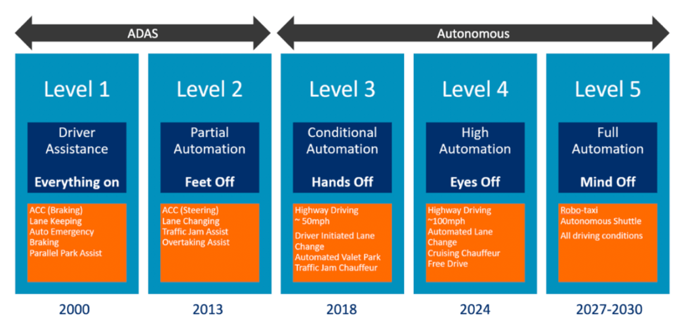

[Side image: simplified version. Includes more examples and year of initial operation. The years at the bottom signify the projected roll out year for each technology, or at this point, for Level 5.]

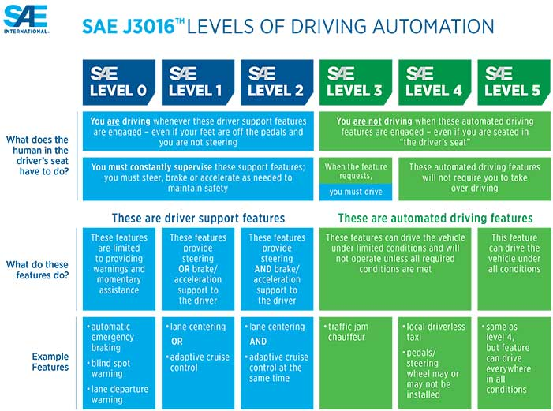

[Main Image: Levels of Autonomy as put out by the Society of Automotive Engineers]

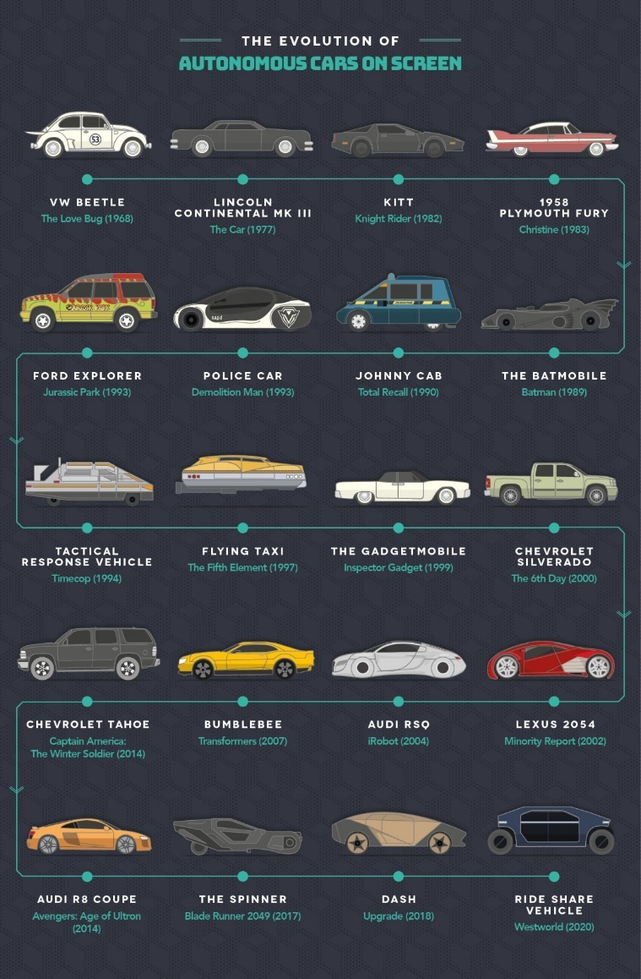[Side image: Evolution of Autonomous Vehicles on Screen]

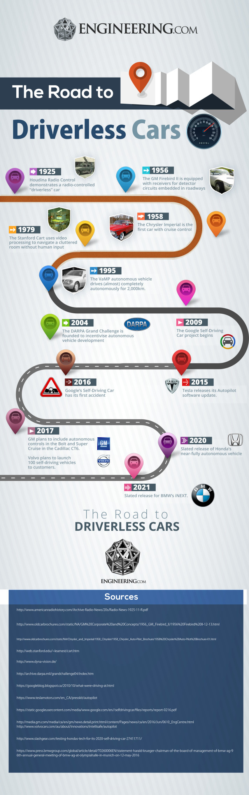[Side Image- This image gives most of the broad strokes of automation history, however, it misses a few key pitstops. 1.) In 1939, Norman Bel Geddes created the [Futurama exhibit](https://www.sensesatlas.com/territory/architecture/futurama-the-prototype-of-the-american-highway-city/) in New York’s 1939 World’s Fair, sponsored by General Motors, and featuring an automated highway. 2.) More importantly to current technological advancements, in 1986, German engineer [Ernst Dickmann](https://www.politico.eu/article/delf-driving-car-born-1986-ernst-dickmanns-mercedes/) outfitted a Mercedes-Benz van with autonomous technology before beginning a partnership with German manufacturer Daimler. 3.) This image mentions the creation of the [DARPA Grand Challenge](https://www.darpa.mil/work-with-us/public/prizes) in 2004, funded by the Defense Advanced Research Projects Agency, a branch of the US Department of Defense. What this image does not mention, however, is that the first two challenges were long distance races located in the Mojave Desert with a 1 and then 2-million-dollar prize. The third challenge, in 2007, was an Urban course, located at an Air Force Base in California. Prizes were again $2 million dollars. DARPA has since continued with autonomous robots, space launch, and subterranean challenges. 4.) In 2015, the [Delphi Automotive](https://www.autoblog.com/2015/04/03/delphi-thrilled-with-results-from-autonomous-cars-cross-country/) driverless car becomes the first AV to cross the US from San Francisco to NYC. It completed it in 9 days. 5.) And in 2016, Singapore introduced its first autonomous taxi service, [MIT’s nuTonomy](https://spectrum.ieee.org/cars-that-think/transportation/self-driving/nutonomy-to-launch-worlds-first-fully-autonomous-taxi-service-in-singapore-this-year), to its streets.

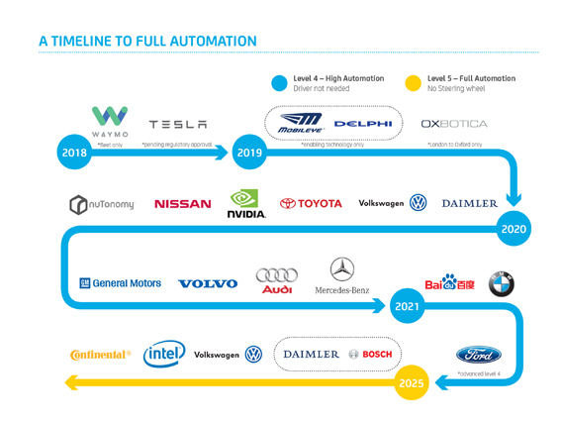

[Side Image – recent tech outlining transition to Level 5 automation]

Looking back at Tom’s story, we don’t see a Level 5 driverless vehicle. Instead, his experience features a human-driven car equipped with AEBs, a form of brake assist designed to help the driver identify and avoid head on collisions, putting this vehicle between a Level 0 and a Level 1. These brakes operate by receiving a command from a computer that receives information from built-in sensors. When these sensors detect possible impending obstacles, they relay that data to the computer, which decides if they are indeed obstacles to be avoided; if so, the computer makes the decision to brake. In other words, AEBs are a low-level form of artificial intelligence (AI).

[Side image: AEBs]

Thus, despite Tom’s brush with moderate AI, these brakes are in fact the immature fledglings of a fully autonomous vehicle. More than that, the AVs of today are intended by some to be the prototype of a nationwide fleet of vehicles. Already, the technology that enables AVs has grown exponentially in the last decade, to the point where we currently see functioning Level 4 vehicles on roadways worldwide (albeit on a trial level as most are still under supervision, and prone to adjustments as the systems run into novel situations). And progress begets progress, as they say. Given this projected eventuality, I believe it’s fair to interrogate the nature of AVs in general, as they are poised to be the next greatest technological advancement since the bread slicer gave us sliced bread.

Driverless-ness, however, is a tall order. While certainly more than the sum of its parts, when disassembled, we can see the complex systems that AVs must employ to function. Among technologies like GPS, automatic braking, steering, and locking, AVs have what Alan Amici, vice president of TE Connectivity, an automotive company at the forefront of sensory technology, identifies as the 3 most essential AV elements: sensors, connectivity, and software/control algorithms.

*Sensors*

Sensors are pivotal to the car’s ability to navigate and more than that, they do the data groundwork, feeding information to the other systems to build from. Sensors must observe their surroundings, detect objects on all sides, navigate curves in the road, etc. We see these sensors in the form of 3 basic technologies working simultaneously: 360-degree LIDAR and radar for object detection[2], cameras for cross-checking object recognition, and ultrasound for park assist. These provide the AVs with a visual field comparable to the human eye, allowing them to “see” as a human would and orient themselves in relation to the objects around them. While at the moment sensors may not outcompete a human eye, several benefits of this technology are that sensors are constantly vigilant, consistent in their estimations, and attending to all sides of the vehicle at once.

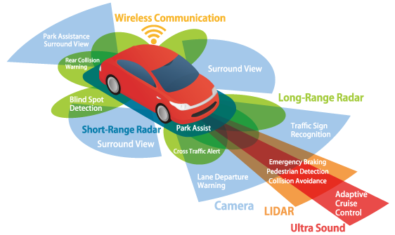

*Algorithms*

All this sensory data, however, is useless to a system that can’t make confident, human-esque decisions; it needs an on-deck computer system to compile information and learn from the data accumulated until it has developed a situationally-aware, and in some ways, superhuman system[3]. In other words, it needs AI. Essentially like a teenager with a learner’s permit, the system garners skill through experience. And in doing so, the algorithm learns to discriminate between ambiguous objects like a plastic bag and a child, a shady patch and a pothole, or highway construction and a cyclist. Among the 50+ companies involved with autonomous vehicles, there are dozens of models available. I’ll discuss one model in more detail later.

But, not only do these models need to identify what they are looking at, they are also need to reconcile speed and direction of surrounding objects. And in doing so, an algorithm should be able to predict the movements of these objects to inform its own navigational decisions. For instance, if the vehicle wants to switch lanes, it must determine if any entity is currently occupying the space it seeks to fill, or if there is an approaching vehicle about to pass. If so, it must calculate that vehicle’s speed and adjust accordingly. Alternatively, if a deer runs across the road, while perhaps unpredictable, it would be useful to know if that deer would already be out of the lane by the time the vehicle gets there. Thus, in calculating the deer’s speed and direction, or in other words, its velocity, the AI may determine if it only needs to slow down instead of stop, perhaps saving its passengers unnecessary stress.

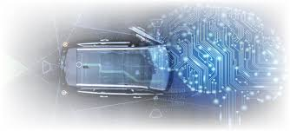[side image: algorithms]

*Connectivity*

Lastly, while the AVs are fully operational with just sensors and algorithms, they also need input from surrounding vehicles or wireless hubs (i.e. connectivity) if they are to be more efficient and operate in proximity. If a vehicle decides to stop because it thinks the plastic bag is a child, it needs to provide a forewarning to the next vehicle that it’s stopping, so the next car may simultaneously and safely stop as well or else provide a wide berth. Additionally, fleets of AVs on the roadway, if not interconnected, may be dangerous. Take for example two AVs on the outside lanes of a three-lane highway keeping pace with each other. What happens when they both want to switch into the middle lane at the same time? Perhaps an improbable situation, but one that could cause an accident, nonetheless. That may only occur, however, if they aren’t able to communicate their intentions and synchronize their movements. Thus, AVs cannot operate on independent systems.

[Side image: connectivity]

More than that, connectivity could boost efficiency in driving. Traffic could synchronize[4], eliminating the-mile-long start/stop jerking; stop lights could become non-existent. In a large intersection, vehicles would automatically make space for each other. An overarching algorithmic system, essentially acting as an air traffic controller, could calculate each vehicle’s route, determine where each AV will be at any given moment, and ultimately, minimize everyone’s time in traffic.

Vehicles could also receive moment by moment reports from traffic and accident centers, like The Department of Transportation, local newscasters, or Google Maps. This could be a boon for a vehicle’s passengers; AVs could automatically switch routes due to road closures, traffic, or iciness, saving passengers time and reducing contact with safety hazards. While I’m not going to focus too much on AV connectivity technology, it’s interesting to note where the connectivity occurs. The picture below summarizes the big 5 in AV wireless tech; it just doesn’t identify the individual objects such as trees, buildings, rocks and the like, which may have sensors attached to them to inform AVs of their location. This could be helpful in circumnavigating unique roadway situations where a tree, for instance, is situated very closely to the road.

[Side image-Connectivity]

**So, what does all this have to do with bikes?**

Bicyclists have had a contentious history with vehicles. Given their lack of protection, when going head-to-head with a vehicle will more than likely result in the cyclist injured if not killed. Most of the time, this is due to simply not seeing the cyclist, either because they are small and often situated below the vehicles line of sight, or, as happens in large cities, they zip through traffic, perhaps coming up on a car unawares. Either way, vehicles are liable to fatally injure a cyclist. Take for example, [Katie Mckenna](https://www.rd.com/article/run-over-by-an-eighteen-wheeler/), a New York cyclist run over by a semi-truck when it failed to notice her while making a right turn at an intersection. She survived and has since become an author and motivational speaker. In fact, the first line of [her book](https://www.amazon.com/How-Get-Run-Over-Truck-ebook/dp/B01LY9PYBR) queries, “So, how do you get run over by a truck? My first recommendation is to ride a bicycle”. This is a sensationalist example, but one that exemplifies a common problem bicyclists have when interacting with surrounding vehicles – a lack of attention.

*Elaine Herzberg*

In March 2018, [Elaine Herzberg](https://usa.streetsblog.org/2019/03/08/uber-got-off-the-hook-for-killing-a-pedestrian-with-its-self-driving-car/) was struck and killed by an Uber owned self-driving vehicle as she walked her bike across an Arizona street. She was the first AV-related pedestrian fatality. It should be noted, however, that a backup driver was behind the wheel (watching The Voice) and the AEBs had been disabled, so the exact degree of the car’s (and by extension Uber’s) fault is indeterminate.[5] It was presumed that the car recognized neither Herzberg nor the shape of her bag-laden bicycle, suggesting a lack of thorough vetting for AV’s bicycle identification models. And similarly to Tom, she appeared out of nowhere, “like a flash” according to the driver, which is what the Tempe Arizona Police Chief Sylvia Moir told a local paper. The difference between Tom’s and Elaine’s incidents, however, is that Tom was the unfortunate recipient of an operational braking system, attempting to circumvent the death of the pedestrian. Elaine on the other hand, was the pedestrian in this case, however, the system was not operational, nor did it detect her existence until it was too late

Without a clear account of what happened, especially from Elaine’s perspective, it’s difficult to parse out the nuance. But essentially, even if the brakes were operational it appears as if the vehicle wouldn’t have had the capacity to avoid her let alone immediately identify her as a human. According to [a report](https://www.ntsb.gov/investigations/AccidentReports/Reports/HAR1903.pdf) put out by the National Transportation Safety Board (NTSB) after the accident, the vehicle had flashed a warning of a potential object in the roadway, but only 5.6 seconds before impact. Within this minute period, the vehicle classified Elaine as another vehicle, an unidentifiable object, a pedestrian, and a bicyclist. Once it finally decided Elaine was an accident waiting to happen, it had 1.2 seconds to react, however, because the brakes had been disabled, it was unable to do so. While ample theoretical inquiry could debate the culpability of Uber and its technological corner-cutting, what is important for this article is why the system wasn’t able to identify her, and furthermore, predict her movements (i.e. how fast she was going, what orientation she exhibited, what direction she was going). And with that, how much did her bike affect the way she was perceived?

*Bike Troubles*

As it turns out, AVs have been having trouble with bikes since their inception. A [Slate article](https://slate.com/technology/2018/02/self-driving-cars-struggle-to-detect-cyclists-bicycle-to-vehicle-communications-arent-the-answer.html) cites UC Berkeley research engineer Steven Shladover acknowledging: “Bicycles are probably the most difficult detection problem that autonomous vehicle systems face.” And it’s no wonder: they are small, swift, and unpredictable. Unlike cars, which have a blocky shape with lots of mass and volume, bikes have a smaller inconsistent shape. Even when bicyclists follow safe legal procedures for switching lanes, the AI can have difficulties interpreting the shapes in its visual field; a bike gets bigger, in a 2D sense, when going from the back to the side views. When viewing the back of a bike, it looks small and compact. And without a holistic understanding of a bicycle’s appearance, it would be hard to predict how far forward the bike extends. So, when viewing a bike from the side, it seems to get bigger and change shape, a seeming improvement for an automated vehicle’s sensing capabilities. However, even this, is easily misinterpreted as the side view has more negative space between the wheels and the frame. Not only that but putting an arm out to signal direction, wearing eye catching clothing, or attaching saddle bags and baskets can change the appearance of a bicycle.

*Head-on Collisions*

As evidenced by Elaine’s tragedy, self-driving vehicles have more head-on collisions than anything else. Vehicle’s in general spend most of their time going forward after all, and most bicycle-AV research has targeted this eventuality. **More on head on collision research**

Thus, Tom’s situation was far from extreme; there were no causalities and no additional vehicles involved, and in relation to AI vehicle collisions, certainly not the norm. Tom was behind the car, and due to its braking system, crashed into it, not necessarily because it didn’t see him, but because in trying to avoid harm to someone else, it slid into his lane.And between these two incidents, is the question of bikes. Tom may have escaped unscathed if the vehicle didn’t swerve into his lane. So, does that suggest a lack of oversight on how the vehicle, upon braking from high speeds, may swerve into a designated and frequently ridden bike lane? And in doing so, is the system designed to prioritize objects in front rather than on either side? If so, the AI in question may not be accounting for bicyclists riding only feet away from the vehicle.

*Right Turns*

But just because his case wasn’t usual, doesn’t preclude Tom’s situation from shedding light on similar events. When San Francisco began rolling out Uber’s new autonomous taxi line in 2016, San Francisco’s Bicycle Coalition wrote a [blog post](https://sfbike.org/news/a-warning-to-people-who-bike-self-driving-ubers-and-right-hook-turns/) detailing the negligent nature of the vehicles’ right-hand turns.[6] These were described as a “right hook” through the bike lane, instead of a gentle cognizant merge, suggesting either a lack of AI sensors or else recognition of bicyclists when located to the vehicle’s right, or a lack of AI training on how to properly merge into the bike lane when executing a right turn. In either case, these vehicles aren’t well trained to share the road with bikes. Uber’s suggested fix here, was to ensure a human driver take over to avoid the AI from negligently rounding the turn, a short-term solution for a long-term problem.

Thus, both Tom’s and Elaine’s experiences epitomize just one potential issue in an emerging technology, or at least, a known pattern in need of further redress, that is bicycle identification and consideration.

**Weeds: what data currently exists? AV Vehicle Safety and Bicycle Accident Stats**

Since the world has had little experience with self-driving vehicles, the data to determine their exact qualifying statistics hasn’t been published or doesn’t exist yet, or at least doesn’t exist to the confidence levels needed to make any meaningful conclusions.

Aside from [the](https://www.gm.com/our-stories/self-driving-cars.html#:~:text=Our%20self%2Ddriving%20vehicles%20aim,contributing%20to%20a%20better%20environment.) [assurance](https://navya.tech/en/solutions/self-driving-custom-solution/) [from](https://zoox.com/wp-content/uploads/safety_report_12dec2018.pdf) [a](https://self-driving.lyft.com/wp-content/uploads/2020/06/Safety_Report_2020.pdf) [variety](https://www.apple.com/ads/ADS-Safety.pdf) [of](https://waymo.com/safety/) [manufacturers](https://group.volvocars.com/company/innovation/autonomous-drive) that automated vehicles are completely safe (full stop), I couldn’t find much on the exact safety data received from testing these vehicles (Google’s Waymo, Amazon’s Zoox, Uber’s line of Volvos, GM, Navya, Apple, Lyft etc.), and I’m unwilling to rely on the manufacturers stamp of approval for their own product. Furthermore, most of these companies, in proclaiming their safety guarantees, are comparing their tech to the statistic that 94% of all car accidents are due to human error, a reasonable assumption given that humans are ultimately in control of the vehicle. It is this ubiquitous 94% however, that seems to be motivating self-driving vehicle manufacturers; half of the hyperlinked mission statements above are dedicated to reversing the 94% trend. But according to many of the current stats reported by AI algorithms (more below), manufacturers have yet to breach the human error benchmark, though that may change in the future.

Brian Wiedenmeier, Executive Director of the San Francisco Bicycle Coalition, presumably in an exclusive [interview with IEEE](https://spectrum.ieee.org/cars-that-think/transportation/self-driving/the-selfdriving-cars-bicycle-problem) also expresses his “excite[ment] about the promise of eliminating” the high human error rate in car accidents, which for cyclists manifests in accidents where the driver wasn’t paying attention, didn’t see the cyclist, drove too aggressively, or resented the cyclist’s use of the road.

46,000 bicycle-related accidents occurred in 2015. In [2018](https://www.bhsi.org/stats.htm) 857 bicyclists died on US roadways; however, I couldn’t pin down a more recent stat of total accidents. According to the National Highway Traffic Safety Administration, bicyclists have [two different kinds of crashes](https://www.nhtsa.gov/road-safety/bicycle-safety): falls or collisions, with the latter resulting in more fatalities. Thus, distinguishing between accident types and receiving relevant deterministic data is a challenging task. However, if we were to assume every crash to be a collision with a vehicle and use the 94% human error rate from before, that means that 43,240 bicycle accidents and roughly 911 bicyclist deaths were due to a human driver. And even if we were to assume that half of those accidents were collisions instead of falls, that’s still 21,620 bicycle accidents in 2015 and 456 fatalities in 2018. In terms of the entire US population that’s still less than 1%, but that shouldn’t deter our population from wanting to improve, and if AV manufacturers are correct in their confidence (in that they are safer for not only passengers and pedestrians but also bicyclists and even wildlife), than perhaps self-driving vehicles should be our future.

Curiously, I also couldn’t find conclusive analyses detailing bicycle accidents in relation to AVs. AEB systems, on the other hand, have been around long enough for studies to produce some exciting, though inconclusive, results; an initial study found that only 2 crashes with pedestrians and/or bicyclists occurred with cars installed with AEB, while 52 occurred without the system installed – a substantial leap, though in reality a poor judge of the value of these systems. This study has a few problems: 1.) This only occurred for head-on collisions 2.) It wasn’t looking at just bicycle-vehicle interactions; instead, it combined bicyclists and pedestrians into the same category so it’s unclear how many of those colliders were bicyclists. 3.) The study was based in Europe; thus, its conclusions are designed for European streets, with European road etiquette. And 4.) The study itself acknowledges that the sample size was too small to make any generalizable statements. At the time the study was running, very few vehicles had AEB installed, thus the range of reliable data was unavailable. But the results tentatively suggest a lower crash rate when vehicles are installed with AEB than not, an exciting prospect for the future of vehicle safety technology.

Uber has subsequently contracted with San Francisco (in 2016) to unveil their line of autonomous taxis, which were recalled (2017), then reinstated with the stipulation of releasing a limited fleet with a human back-up behind the wheel (2018).

**Here’s why the Biggest Problems for AVs and Bicyclists**

**(Deep3DBox image interpretation software)**

[Research](https://scholar.google.com/scholar?hl=en&q=Sucha%2C+M.+%282014%29.+Road+users%E2%80%99+strategies+and+communication%3A+driver+pedestrian+interaction.+Transport+Research+Arena+%28TRA%29%2C+April+14%E2%80%9317%2C+Paris.) suggests too, that eye contact and nonverbal communication between cyclists and drivers is invaluable to cyclists in communicating their intentions and receiving the assurance that drivers see them in return. Just as bicyclists are small and unpredictable for AI, so too can drivers be caught off guard with a previously unnoticed bicyclist. The ability to communicate via gestures and eye contact substantially bridges this gap with drivers. For instance, when a bicyclist is trying to cross an intersection with oncoming traffic, they will make eye contact with the driver and behave as if they are waiting to cross. This accomplishes relaying to the driver it is the cyclist’s turn and knowing that the driver has seen them on their bike and will slow down.

With this in mind, one potential [solution](https://techcrunch.com/2017/09/07/tome-software-and-trek-bicycle-are-looking-to-ai-to-make-biking-safer/) is for bicyclists to install sensors on their bikes or helmets that will beep or vibrate when the vehicle is within range. Once the sensor has communicated with the vehicle, the operating machine will acknowledge a bicyclist is near, while the beeping assures the helmet wearer that the vehicle has seen them. This could also be revolutionary for normal drivers as well, who can have trouble identifying a bicyclist especially in the dark, rain, or the vehicle’s blind spot. In implementing this technology, an automated car would locate a bicycle in its back right corner and know to give the cyclist more space. Like anything, this has its own set of problems. If the sensors aren’t communicating with the visual field information, then the vehicle can’t assess the shape of the bicyclist, i.e., if the sensor is at the front of the bike the car might run into the back since it doesn’t know how long it is. Also in order for this system to be effective, it would require management and production on a national scale. Without synchronizing all vehicular and pedestrian sensors, the vehicles can’t calculate their movements in relation to the space and people around them adequately. And if the sensors aren’t communicating with the visual field information, then the vehicle can’t assess the shape of the bicyclist, i.e., if the sensor is at the front of the bike the car might run into the back since it doesn’t know how long it is.

AI research from the manufacturers and the national agencies alike suggest less collisions in the long run with automated vehicles than manually driven ones. If this is true, perhaps to make that transition happen more smoothly, and to improve our infrastructure, we should engineer safer traffic flows. I believe many risks can be mitigated by improving complex and narrow roadways, for wary human drivers, and especially for AI that is unequipped to handle unusual or ambiguous intersections. Furthermore, we need to develop better lanes and designated pathways for bikes on our streets and caution bicyclists to ride more predictably, that is with consistent movements and assurance they will stay as much as possible in designated lanes. Automated vehicles [trained on consistent movements](https://www.tandfonline.com/doi/full/10.1080/19439962.2019.1591556?scroll=top&needAccess=true) will better understand what it’s looking at if bicyclists behaved more predictably. And on the flip side, the AI in question should also behave more predictably, i.e. behave as if a human was behind the wheel. Bicyclists, unsure of how automated vehicles will react, may change their behavior if they think it may help the AI ‘see’ them better. HCI

**Case Against AVs – or else, why AV’s may not be what we need**

**Conclusion**

Tom’s story could easily be extrapolated out by substituting the AEBs in the car with an inexperienced driver still fine-tuning their reflexes. If that were the case, this story wouldn’t hold water in terms of notoriety or novelty, especially as no fatalities occurred. Tom and the driver would have both been under the influence of dumb luck. But this same logic could be applied to most automated vehicle accidents; since automated vehicles are a nascent system still under development, it is comparable to your average American teenager with their learner’s permit. Thus, this technology needs experience via thorough testing and analysis, a mission that should be interrogated.

So, who is accountable? How do you prevent this from happening in the future? Even more than that, would a world where automated vehicles are the norm make bicyclists feel safer or more vulnerable on the road? On the flip side, how can bicyclists and drivers alike be aware of this future reality and the accompanying side effects?

These are just some of the questions to ask, to get a clear picture on how to address this problem. As the driver had little agency here, there is an argument for negligence on the part of the manufacturer. If this had occurred in a different setting, let’s say a crowded city street, with motorists and pedestrians on all sides, imagine the potential for damage or fatalities. Like I am excited by this technology and curious of the potential. I believe self-driving vehicles could revolutionize the basic structure of our society, redefine the nature of work, and reprioritize American decision making. Despite finding its foothold in society, I believe this example underscores the need for further policy redress around AI, and especially further machinery testing and risk modeling.

Outside of bikes, does it suggest too, an under-developed system seeming to have disregarded how quickly the pedestrian was moving? If it had taken speed and direction into account, would it have braked so suddenly? Or would it have gradually decelerated, providing time to make a calculated decision once it had determined the pedestrian’s movements?

Yet, that is unfortunately a flawed argument. While a self-driving vehicle would by design eliminate the human element, it doesn’t mean that the replacement machinery would be better than the 94% error rate; essentially, removing people doesn’t mean removing errors. It could, in fact, be much worse.

however according to [this article](https://www.uci.org/news/2020/2020-cycling-boom-in-the-usa) biking increased by 253% in April 2020 after the start of pandemic. While this may follow you classic boom and bust story of a fad industry, if this trend continues, we need to massively overhaul the magnitude of biking operations in the US, which includes weighting bicyclists differently AV vehicles sensor-ship.

1. Before the update there were only 5 tiers going up to Level 4. Level 4 then developed a part (a) and (b). It was eventually bisected into two separate levels. Images detailing AV tech, history, and projections refer to fully autonomous as Level 4 or Level 5.
2. [This article](https://www.thedrive.com/article/16916/lidar-vs-radar-pros-and-cons-of-different-autonomous-driving-technologies#:~:text=First%20of%20all%2C%20what's%20the,for%20Light%20Detection%20And%20Ranging.&text=Radar%20uses%20radio%20waves%20to,light%20rather%20than%20radio%20waves.) discusses what lidar and radar do, their differences, pros and cons, and which of the two sensors individual AV companies prefer
3. I won’t go into the different kinds of AI models employed by AV’s, however [this article](https://www.jdsupra.com/legalnews/the-basics-of-autonomous-vehicles-part-35016/) details many of the commonly used algorithms.
4. Check out [this video](https://www.youtube.com/watch?v=iHzzSao6ypE&t=253s) on how phantom traffic forms and [this video](https://www.youtube.com/watch?v=TNokBgtSUvQ&t=255s) for a more detailed look. While I like the first video for its ability to provide more information in less time, the animation in the second video is hard to beat.
5. Check out [this Medium article](https://onezero.medium.com/who-killed-elaine-herzberg-ea01fb14fc5e), which features an excerpt from *Who’s Driving Innovation*, a book by University of College London Associate Professor in Science and Technology Studies, Jack Stilgoe. It discusses every individual agent’s involvement and culpability in this tragedy, and how we can learn from it for future innovation
6. This series isn’t designed to target Uber. But Uber more than any other emerging AV tech company has been the most error prone, mostly for the fact that they are rushing to be the first AV in the market, and it’s been reported, that in doing so, they’ve flouted many of the safety tests and thorough tech that their competitors engage in.